Final Report

July 2017

- Team Name:

Hello 215

- Team Members Name and NSID

Name: Yinsheng Dong (yid164)
Name: Hao Li (hal356)
Name: Zhihao Lin (zhl798)
Name: Jinyang Liu (jil167)
Name: Yanzhao Lu(yal121)

- Project Name

Student Information Record System.

- Project Description
A recording system use MIPS assembler. This system is for class grade recoding. When a new student rolls into the class, there is an array to store students, will store name, student number, assignment grades, midterm exam grades, final exam grade. It can show a student’s information also final grade by calling a function, this function includes a method to calculate final grade by proportion. Also, can show all students’ information in this class. If a student is no longer in this class, we can delete this student. There could be a function to modify grades. We can calculate average grade for every assignment, midterm exam and final exam for all students.

- Project Design

This is our flow chart:
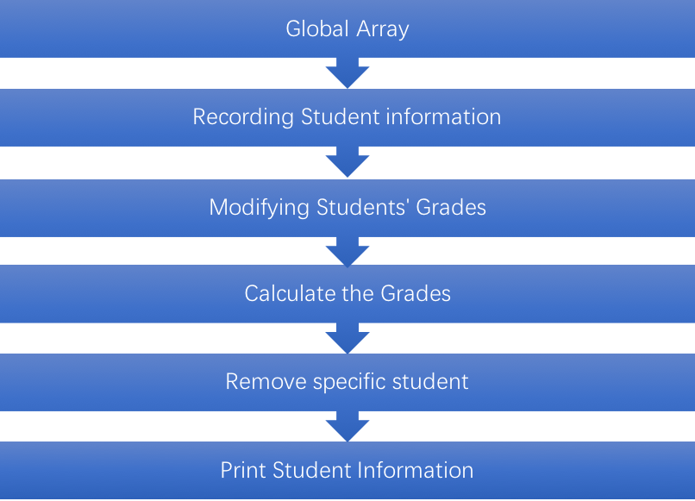

- Global Array: Save student information needed for the System
- Recording Student information: Allows user to enter the student name, then record the student name, create unique student ID for the student. And initialize the grades.
- Modifying Students’ Grades: User can modify/update specifically student’s grades by enter student’s ID.
- Users can calculate the final grade of a specific student, or the average grade of assignments/exams for all students.
- Remove specific student: Users can remove a student from the array by entering ID
- Print Student Information: The program can print specifically student’s information by searching ID, or print all student’s information in an array.

We will use 16-bit graphic display in our project, Our mock design:
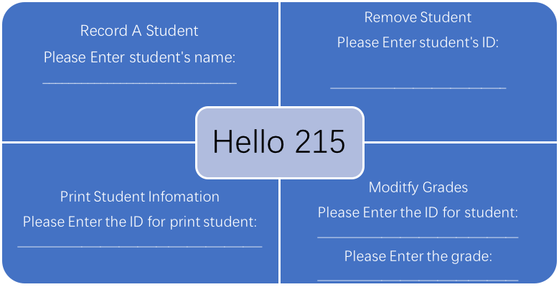
We will try to do this, but the real thing will be slightly different.

- Failures

The modification part is difficult to realize. We can get student’s information from the array, but we could not allocate the specific part and change it. Array in MIPS may be different than in other language. Also, we couldn’t combine the average calculation function with system. For calculating average grade, we write algorithm code, but we don’t know how to extract the mark from the array.

